Topology:
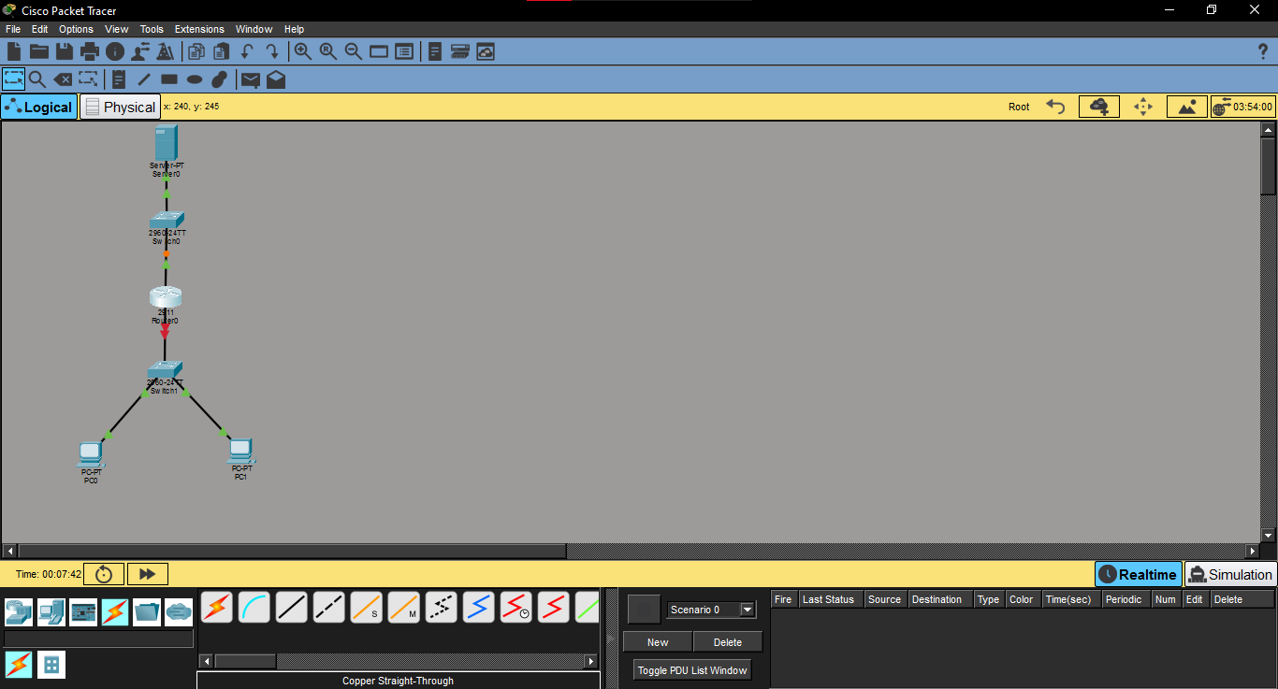

Interface Status:
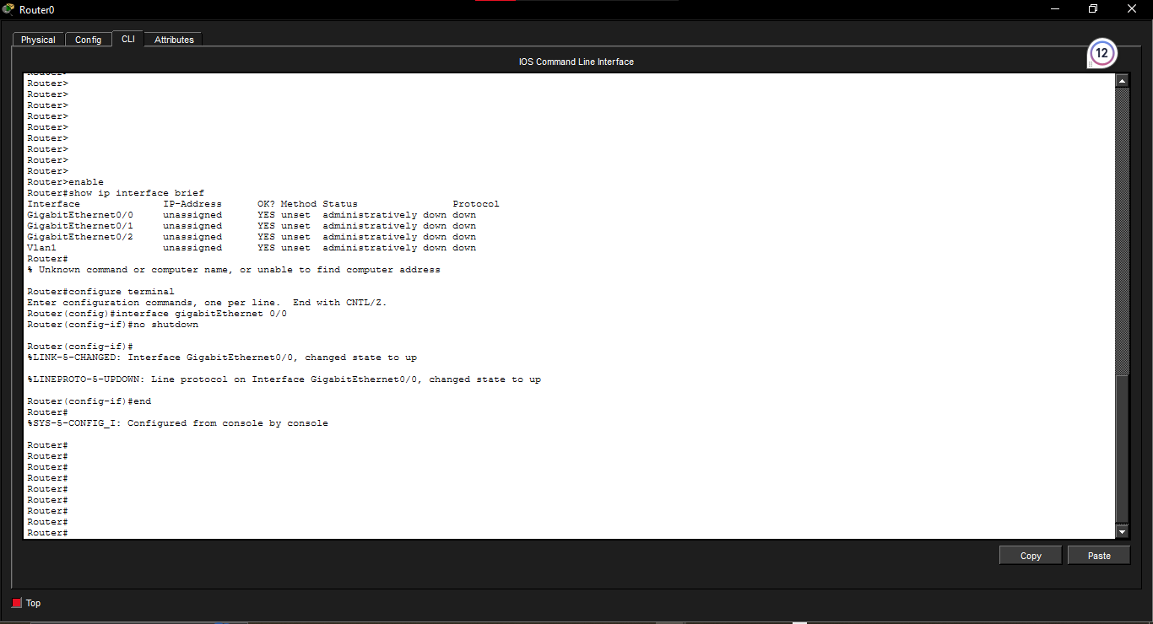

Task97: Router1 DHCP Address
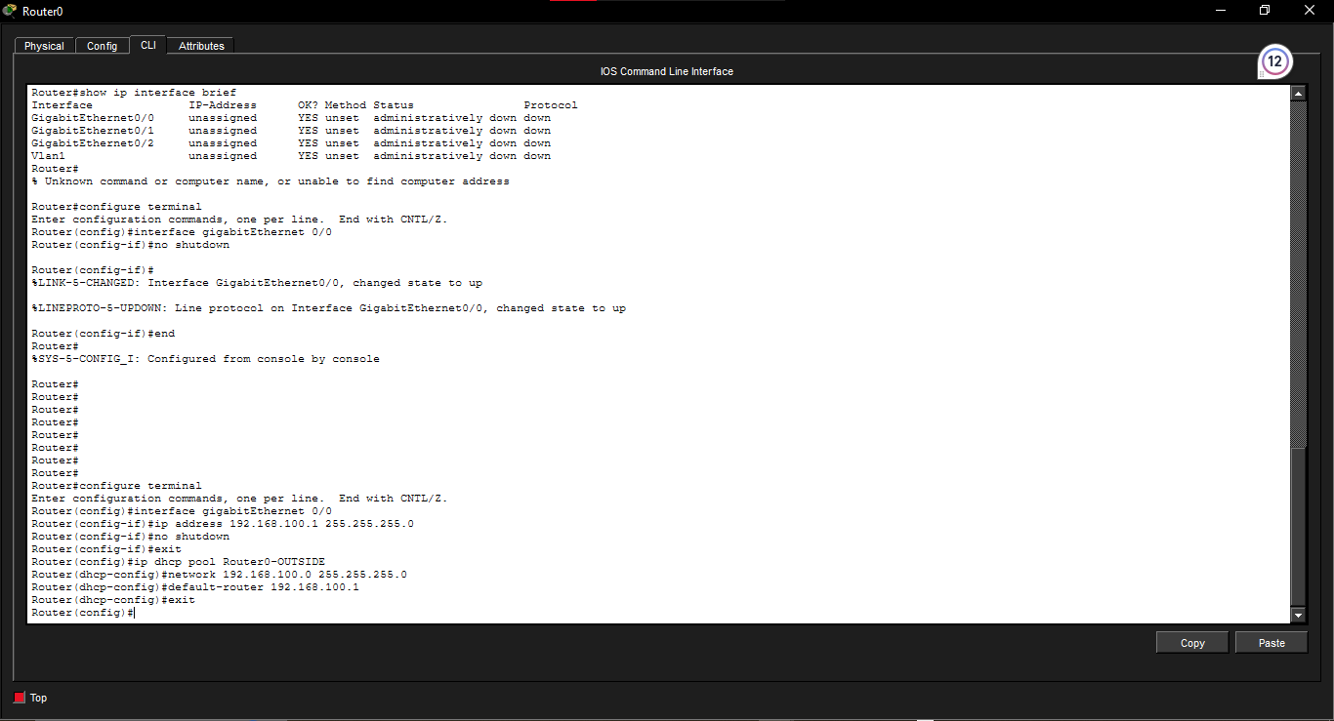

Task97: Service Provider DHCP Pool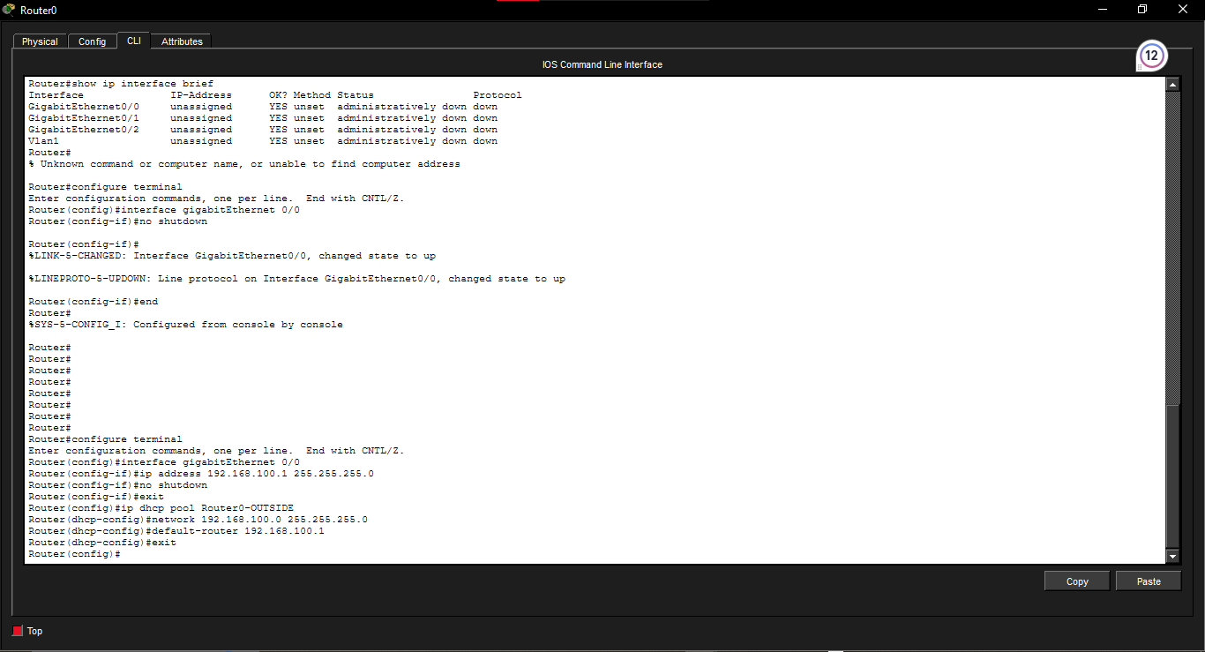

Reflection Question
An ip helper-address is needed when the DHCP server is on a different subnet because DHCP discovery messages are broadcasts, and routers do not normally forward broadcasts between networks. The helper address allows the router to forward these requests to the external DHCP server. When the server and client are on the same subnet, the broadcast can reach the server directly, so an IP helper address is generally unnecessary.

